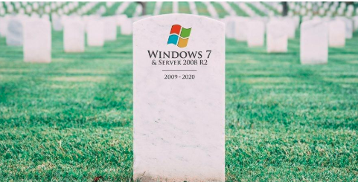

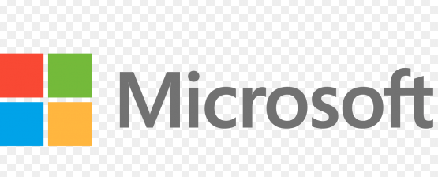
Windows 7 support will end on January 14, 2020
Applies to: Windows 7

Windows 7 support lifecycle
Microsoft made a commitment to provide 10 years of product support for Windows 7 when it was released on October 22, 2009. When this 10-year period ends, Microsoft will discontinue Windows 7 support so that we can focus our investment on supporting newer technologies and great new experiences. The specific end of support day for Windows 7 will be January 14, 2020. After that, technical assistance and software updates from Windows Update that help protect your PC will no longer be available for the product. Microsoft strongly recommends that you move to Windows 10 sometime before January 2020 to avoid a situation where you need service or support that is no longer available.

Frequently Asked Questions

What does end of support mean for me? After January 14, 2020, if your PC is running Windows 7, it will no longer receive security updates. Therefore, it’s important that you upgrade to a modern operating system such as Windows 10, which can provide the latest security updates to help keep you and your data safer. In addition, Microsoft customer service will no longer be available to provide Windows 7 technical support.
What should I do? For most Windows 7 users, moving to a new device with Windows 10 will be the recommended path forward. Today's PCs are faster, lightweight, yet powerful and more secure, with an average price that's considerably less than that of the average PC eight years ago.

Can I upgrade my existing PC to Windows 10? To take advantage of the latest hardware capabilities, we recommend moving to a new PC with Windows 10. As an alternative, compatible Windows 7 PCs can be upgraded by purchasing and installing a full version of the software. For more information, see Windows 10 upgrade FAQ.

What happens if I continue to use Windows 7? You can continue to use Windows 7, but after support has ended, your PC will become more vulnerable to security risks and viruses. Windows will continue to start and run, but you will no longer receive software updates, including security updates, from Microsoft.

Can Windows 7 still be activated after January 14, 2020? Windows 7 can still be installed and activated after end of support; however, it will be more vulnerable to security risks and viruses due to the lack of security updates. After January 14, 2020, Microsoft strongly recommends that you use Windows 10 instead of Windows 7.

Will Internet Explorer still be supported on Windows 7?
Support for Internet Explorer on a Windows 7 device will also be discontinued on January 14, 2020. As a component of Windows, Internet Explorer follows the support lifecycle of the Windows operating system it’s installed on.
What if I’m running Windows 7 Enterprise?
If you are using Windows as part of a work environment, we recommend you check first with your IT department or see Windows 10 deployment support to learn more.
What about Windows 7 Embedded?
Windows for embedded devices such as ATMs or gas pumps have lifecycle dates that sometimes differ from versions of Windows that are used on PC devices.

