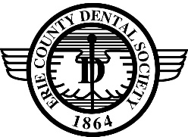
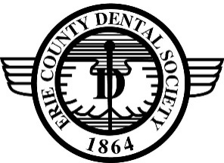
Erie County Dental Society
Presents
Basic Life Support for Health Care Providers
Given by The Safety Company

4 MCE Credits
Provided by Eighth District Dental Society

May 4, 2026 ** 5:00 – 9:00 PM
Eighth District Dental Society Office ~ 3831 Harlem Road ~ Buffalo, NY 14215

Course Description
This course fulfills the NYS course requirements for CPR re-training (current or recently expired card). Participants must complete both a skills test and written exam to be certified. Certification provided by the American Safety & Health Institute.

Schedule
5:00 PM - Registration & Dinner* 5:30 PM – Seminar
*Please notify us of dietary requests (vegetarian, gluten-free, etc.)

Cost:
$70 - Erie County/8th District Dentist $70 – Staff/Hygienist/Assistant $100 - Non-member Dentist

Deadline:
Three days prior to Event

Registration is limited to the first 25 registrants

Refunds will be issued to individuals who cancel more than 72 hours prior to the event. Thank you for your cooperation.

The Erie County Dental Society makes every effort to present high caliber speakers in their respective areas of expertise. The presentations of these speakers in no way imply endorsement of any opinion, product, technique or service in the course of any presentation. Erie County Dental Society specifically disclaims responsibility for any material presented. Programs may be subject to change due to circumstances beyond our control.
Eighth District Dental Society is an ADA Recognized Provider approved by New York State Dental Association. ADA CERP is a service of the American Dental Association to assist dental professionals in identifying quality providers of continuing dental education. ADA CERP does not approve or endorse individual courses or instructors, nor does it imply acceptance of credit hours by boards of dentistry. Eighth District Dental Society designates this activity for four (4) mandatory continuing education credit hours. Concerns or complaints about a CE provider may be directed to the provider or to ADA CERP at www.Ada.org/CERP.

- - - - - - - - - - - - - - - - - - - - - - - - - - - - - - - - - - - - - - - - - - - - - - - - - - - - - - - - - - - - - - - - - - - - - - - - - - - - -
Erie County Dental Society – Basic Life Support for Health Care Providers
February * May * August * November 2026 5:00 – 9:00 PM Eighth District Office

Name(s): _______________________________________________________________________________________________________________
Name(s): _______________________________________________________________________________________________________________

Amount Enclosed: $ ___________________ Check No.___________ Or Charge My ______ Master Card _______ Visa

Credit Card # _____________________________________________________________________ Exp: ____________ CVV: _____________

Billing Address: ______________________________________________________________________ Billing Zip Code: __________________

Phone Number: _______________________________________ Signature: ________________________________________________________

Please remit with Check or Credit Info to: ZELLE PAYMENT INFO:
Erie County Dental Society, 3831 Harlem Rd., Buffalo, NY 14215 Email: jcraig@8ddsny.org
Credit Card Users May Register by Phone at (716) 995-6300 or by fax at (716) 995-6305 Phone: 716-628-1867

